ES2C6 Electromechanical System Design Group Project: ROBOTIC HAND

Contents

Team Members 1

Introduction 1

Initial Concept Thoughts: 2

Materials Received: 3

Design 4

Overview 4

Development of distinct designs 5

Design Evaluation 7

Design Selection and Justification 7

Summary Design Calculations 7

Manufacturing Drawings (CAD) 7

Analysis of results 9

Conclusion 10

References 10

# Team Members

* Sam Packer 2103666
* Ellen Nixon Anton 2162918
* Amirah Olawale-Sanni 2115824
* Isabel Okai 2148160
* Jody Nwaelene 2100350
* Osi Obomighie 2137813

# Introduction

The aim of the project is to design an autonomous grip for a robotic hand using materials provided as well as ordering any extras required. To be able to complete this project, we had to build a circuit on a breadboard, do a substantial amount of programming, 3D printing as well as understanding the best solutions to resolve electronic issues we faced during the process. Overall, we were able to…

# Initial Concept Thoughts:

In the first session we were given instructions on wiring the robot hand and connecting it with the motor driver and Arduino Uno. This allowed us to gain an understanding on what would need to be done during our project and the particular areas we would need to focus more on such as taking inputs from sensors and using the Arduino to output a feedback response using a feedback loop and PID control.

We collated our thoughts on what we together thought would be the best direction to take the project in. We considered a simple gripper mounted to a handheld plate but thought it would lack complexity where we could develop a more advanced system. Hence, we agreed on instead creating an articulated robotic arm with a gripper mounted at the front and using servo motors to move sections of the arm in different directions and planes to achieve motion.

Pictured are some notes and initial thoughts of the motion of our arm and the components and processes need to achieve the project.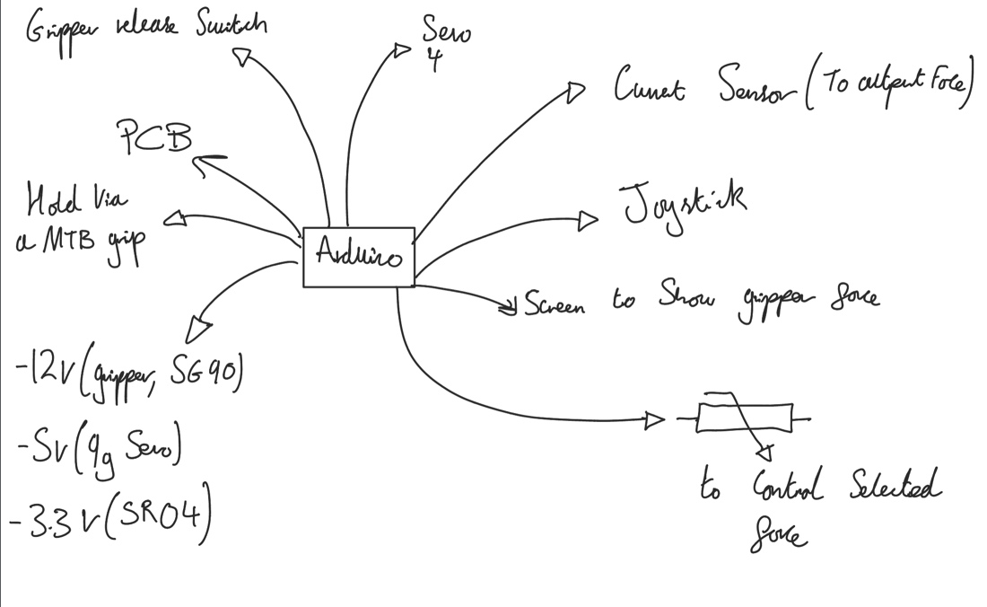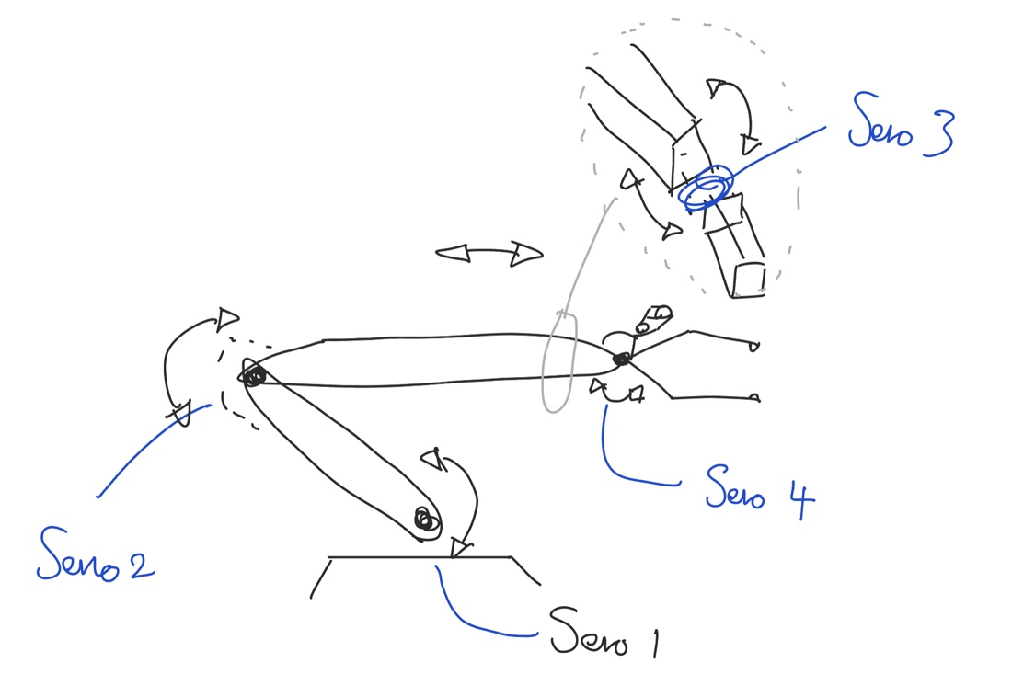

During the process of designing the initial robot arm, the team planned to the wiring into ridges (as shown in Render 1 and Render 2) which would mean less printing required of additional components. The robot hand would have been mounted on a square based end allowing it to ‘stand’ without being held despite the shape also being perfect in terms of the ease of grip. After some consideration this design was not followed through and modified because of the difficulty in permanently attaching the wiring onto ridges without them falling out. The team also realised it would be difficult to organise the wires in a way for the overall design to look exemplary. As a result, the exposed wires could lead to our design looking quite messy and not up to standard. The loose wires also have the potential of getting snagged in the motion of the sections, resulting in failure from a disconnected cable.

***Render 1***

***Render 2***

***Photograph 2***

***Photograph 1***

# Materials Received:

• Makeblock Robot Gripper with 12V DC Motor x1

• Makeblock Me Dual DC Motor Driver (possibly with soldered line socket) x1

• Arduino Uno board R3 (or comparable) x1

• USB2 3m A male to B male cable x1

• Interlink Electronics 0.2” diameter force sensing resistors x2

• 360 tie point prototyping breadboard x1

• 10K resistors x3

• OP177GPZ Ultra-Precision OP Amps x2

• HC-SR04 Ultrasonic Distance sensor x1

• Breadboard jumper wires (various colours, sizes)

• 12V, 1A, 12W, Plug In Power Supply

• Adafruit Adapter, 2.1 mm DC Jack - 2 Position Terminal Block

• ELEGOO UNO R3 Project Super Starter Kit

We also received a £200 discretionary budget, excluding the costs of the components. This left us with £100 to purchase additional components which we used to buy the components as shown in Table X. supplier technician ..

|  |  |  |  |  |  |  |  |
| --- | --- | --- | --- | --- | --- | --- | --- |
| Component Description | Manufacturer | Manufacturer Part Number | Supplier | Supplier Part Number | Quantity | Unit Cost (£) | Total (£) |
| Servo 9g | Rapid | 37-1330 | Rapid | 37-1330 | 1 | 5.03 | 5.03 |
| Whadda Joystick x2 | Whadda | 73-4637 | Rapid | 73-4637 | 1 | 9.07 | 9.07 |
| Hi Tec Servo | HiTec | 64-1479 | Rapid | 64-1479 | 2 | 14.4 | 28.8 |
| Wires |  |  |  |  |  |  |  |
| Total |  |  |  |  |  |  | 42.9 |

# Design

## Overview

Most robots in the world are designed for heavy, repetitive manufacturing work. They handle tasks that are difficult, dangerous, or boring to human beings.

For example, the robotic arm is frequently used in manufacturing roles. A typical robotic arm is made up of seven metal segments, joined by six joints. The computer controls the robot by rotating individual servo motors connected to each joint (some larger arms use hydraulics or pneumatics).

Unlike ordinary motors, servo motors consist of a DC motor and a potentiometer attached to the axle of the output of the DC motor. This potentiometer, often 10KOhm, gives a feedback signal to the onboard processor of the servo motor which computes this as a degree of motion from 0 to 270. The servo motor requires a PWM input which can be delivered from the Arduino Uno using one of the 5 PWM pins. Given the motor controller for the Makeblock gripper also requires one PWM input, that means we are limited to 4 servo motors using solely the Arduino Uno to control them. Knowing this influenced the design of our arm mechanism and we decided to not include rotational motion about the origin of the arm. We did look into the use of a servo control module from Adafruit such as the 16 servo board pictured bellow that can operate up to 16 servo motors using only Tx and Rx pins with I2C communication. However, we felt we did not need to pursue this. 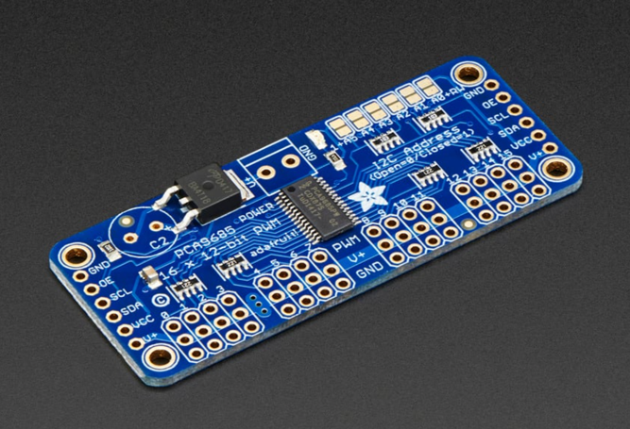

Here is an initial sketch to highlight the initial design thoughts.

https://science.howstuffworks.com/robot2.htm

## 

## A picture containing text, indoor, office, blue Description automatically generatedDevelopment of distinct designs

***Photograph 3***

***Photograph 4***

The components above in Photograph 4 are ultrasonic sensors which emits ultrasonic sound waves and converts it into an electrical signal. The first component in white was the initial 3D print but then the team realised it was too small to fit the robotic hand, so the dimensions were adjusted, and the team reprinted it in blue to give an ultrasonic sensor that fits the design. This was an issue we faced which meant that we had to go back on our design but as this was very early on in the project, we were not pressed for time.

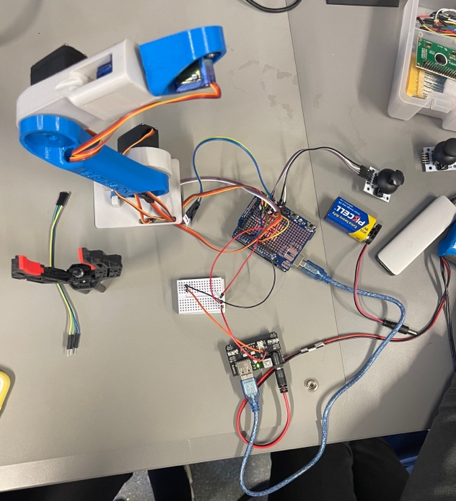

***Photograph 5***

Halfway through the time given for the project, we had made a lot of progress. We tried out the joysticks we had purchased and were trying to move the Servo 4 which controls the hand/ grip of the robotic arm. The team was able to add Servo 3 in the joystick however the battery of Servo 3 was too big which meant a power source needed to be added (since each motor’s maximum draw is 2.5A). This was done and it worked successfully. The only issue at this point was troubleshooting with code on Arduino.

## Design Evaluation

## Design Selection and Justification

On the second week of the project, the group had been able to 3D print out the main body of the robotic arm. This included space designated for the wiring to be tucked away neatly and

# Summary Design Calculations

# Manufacturing Drawings (CAD)

Decided to increase complexity of design, splitting robot arm into parts, also for ease of 3D Printing

Arm A

Sever to be attached on rectangular gap, then robotic arm to be attached onto other side (circular hole)

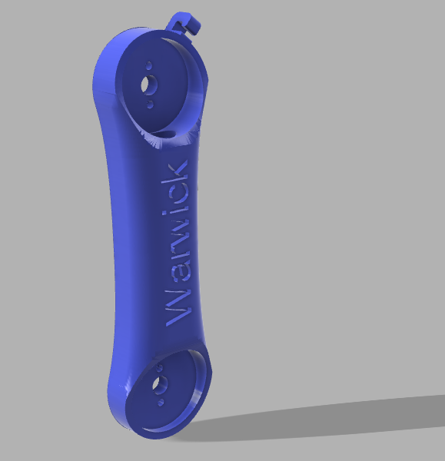

Arm B

Robot arm to be attached onto, then other side attached onto the base

Gripper base, for ultrasonic sensors to be attached to

# Analysis of results

# Conclusion

# References